Rotational (angular) Momentum
Angular Momentum: The measure of how difficult it is to stop a rotating object.
Angular momentum = (mass)(velocity)(radius) or L = mvr Additionally, L = (rotational Inertia)(rotational velocity) = Iω
The SI unit for angular momentum is the kilogram meter squared per second (kgm²/s).
Think of angular momentum as being the rotational equivalent of momentum. Just as momentum is the product of the mass and the velocity, angular momentum is the product of the mass and the velocity for an object rotating at a distance “r” form the axis. Or if the
moment of inertia is the equivalent of “mass” and the angular speed is the equivalent of “velocity”, then Angular momentum = Iω = L
Momentum is conserved when no-outside forces are acting. Similarly, angular momentum is conserved when no outside torques are acting. A spinning ice skater has angular momentum. When the skater pulls her arms in (decreasing her radius of spin and moment of inertia), she spins faster (increasing her angular velocity). Doing so conserves her angular momentum.
- Explain this diagram:
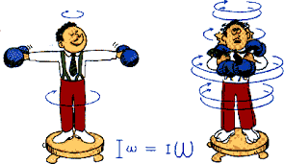
- Explain this diagram:
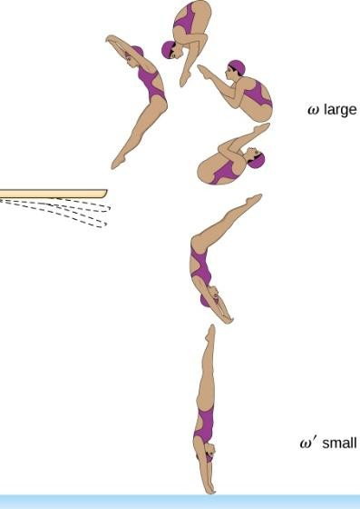

- Jupiter orbits the sun with a speed of 2079 m/s at an average distance of 71,398,000 m.
a) If Jupiter has a mass of 1.90 X 10²⁷kg, what is its angular momentum as it orbits?

- Hickory dickory dock, the 20.0 g mouse ran up the clock, and took turns riding on the 0.20 m long second hand, the 0.20 m long minute hand, and the 0.1 m long hour hand. What was the angular momentum of the mouse on the each of the three hands? (remember, ν = 2𝜋r/T)
- In a physics experiment, Ingrid, the ice skater, spins around in the rink at 1.2 m/s with each of her arms stretched out 0.70 m from the center of her body. In each hand she holds a 1.0 kg mass. If angular momentum is conserved, how fast will Ingrid begin to spin if she pulls her arms to a position 0.15 m from the center of her body. (Use L = mvr)
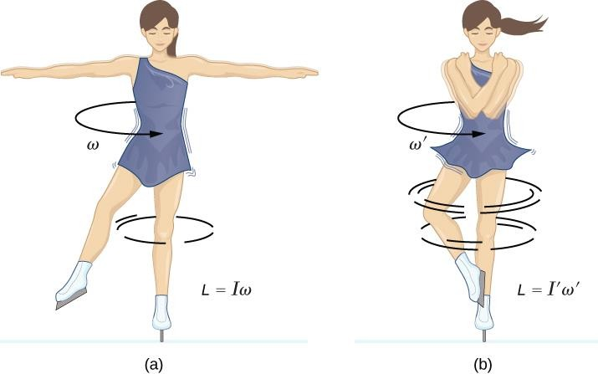
- Mr. Lindsay sharpens a knife on a grinding wheel whose angular momentum is 27 kgm²/s. The 5.0 kg wheel has a radius of 0.30 m. What is the linear and rotational speed of the wheel?
